Name: Cameron Wirtz
District: LAUSD
School: XXX Middle School
Grade: 6-8 Intermediate
Date: 2-3-2019
Lesson Plan Number: 1

National Standards for Music Education:
PERFORMING
- Analyze- Analyze the structure and context of varied musical works and their implications for performance
-MU:Pr4.2.E.5a Demonstrate, using music reading skills where appropriate, how the setting and formal characteristics of musical works contribute to understanding the context of the music in prepared or improvised performances.

RESPONDING
-Interpret- Support an interpretation of a musical work that reflects the creators’/performers’ expressive intent.
-MU:Re8.1.E.8a Identify and support interpretations of the expressive intent and meaning of musical works, citing as evidence the treatment of the elements of music, contexts, and (when appropriate) the setting of the text.

California Visual and Performing Arts Content Standards
2.0 CREATIVE EXPRESSION: Creating, Performing, and Participating in Music
-Apply Vocal or Instrumental Skills
-2.1 Sing a repertoire of vocal literature representing various genres, styles, and cultures with expression, technical accuracy, tone quality, vowel shape, and articulation—written and memorized, by oneself and in ensembles (level of difficulty: 2 on a scale of 1–6).

-2.2 Sing music written in two and three parts.

Objectives
- Students will be able to identify differences in phrasing and word stress in the piece, Autumn by Andy Beck S.S.A by watching, listening, and discussing with one another in the section.
- Students will be able to correctly speak the rhythm and words of the entire piece, Autumn by Andy Beck using the takadimi system in certain areas of the piece.

Equipment and Supplies
- Piano and accompanist
- Pencils
- Metronome
- Recording of Autumn by Andy Beck
  - speaker, projector, internet, computer
- Copies of the piece Autumn by Andy Beck S.S.A

Procedure
- Divide the classroom into voice parts
  - S.S.A
- Begin with a choral warm up
  - Lip buzzing not on pitch
  - Zi-a warm up
    - 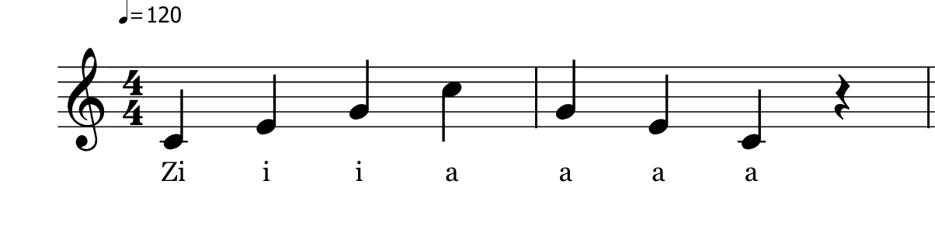
    - Focus on open vowels and sharp consonants
    - Sing from C4-A4
- Discuss the background of the piece “Autumn”
- Listen to a recording of “Autumn”
  - Ask students to follow along in their part and analyze the diction, posture, phrasing, articulation, breath support, and word stress of the singers
  - Ask students how the choir can apply some of these positive and negative observations to the ensemble
- Speak the entire piece focusing on rhythmic elements and phrasing elements while playing pitches on the piano
  - Use the takadimi method for difficult rhythms
- Run through the A-section and B sections on pitch with piano playing individual parts and a mix of the accompaniment (mm. 1-25)
  - Should either part fail, instructor will isolate each section accordingly
    - instructor will correct vowel formants, posture, dynamics, and breath support
    - Emphasize to the Soprano 2 part that their part needs to come out because they are usually the third of the chord
    - Show the harmonic changes through conducting and verbal cues
      - examples
        - Crescendo at measure 12
        - Mezzo piano for the entrances at the A section
    - Correcting breath
      - Examples
        - Prepared breath for Altos at pickups to measure 5
        - Prepared breath for Soprano I and II at pickups to measure 9
  - Repetitive text (mm. 5-12)
    - Space between “long” and “summer” in measure 8
      - Different color because of part change
      - Resets the listeners ear
    - Word “now” needs to connect to “summer” in measure 10 – 11)

Evaluation:

At the beginning of the lesson, many of the students seemed tired, as it was early in the morning. Doing jumping jacks helped the students gain more energy. By being enthusiastic in my demeanor, I could see that the students initial attitude changed as well. The students asked follow-up questions about the style and phrasing that I had suggested in class. This showed that they were interested and invested in learning the piece. The simplicity of the piece allowed for the students to work on finer details. For the students that struggled with the pitches, the speaking of the text with added word emphases helped the students shape each phrase and gave the students a sense of direction when they added pitches to the words.

Extension:
I incorporated many of the aspects that were in my lesson plan. Since I was teaching a piece with an ensemble I had never rehearsed with before, I had to make decisions based upon what I heard in the moment during the rehearsal. Some of these decisions were not originally in my lesson plan. For example, the rehearsal was at 9:00am and the ensemble seemed tired and unenthused to be there. For the warm up, I added jumping jacks to get the body and mind activated. For the next lesson, I will incorporate the same concepts discussed above such as the warm up, vowel formants, dynamics, posture, and breath support for the A’ and B’ sections. First, I will run through A’ and B’ sections with the piano playing individual parts. If either part fails, I will isolate each section accordingly and correct what is necessary. I will emphasize and isolate certain moving lines that create the shape in the A’ and B’ sections as the ensemble had a lot of trouble keeping to their own parts when there was a moving line that created dissonance between the harmony. The ensemble seemed to be buried in their music, so for the next lesson students should be reminded to keep their head out of their music as the final B’ section has ritardando, tempo changes, and dynamic changes as well. Once these details have been addressed the ensemble should sing all combined A, B, A’, B’ sections. Re-assess the ensemble

Assessment Plan:
- Students can be assessed on the accuracy of their diction, posture, phrasing, articulation, breath support, and word stress through sextet group testing. A rubric can be used to grade the accuracy of each assessment category.
- Each time the choir sings, the director can assess the rhythm elements of the piece by listening for the ensemble’s cutoffs and the rearticulating of beginnings and endings of words.

