Name: Cameron Wirtz
District: LAUSD
School: XXX Middle School
Grade: 6-8 Intermediate
Date: 2-3-2019
Lesson Plan Number: 1

National Standards for Music Education:
PERFORMING
- Analyze- Analyze the structure and context of varied musical works and their implications for performance
-MU:Pr4.2.E.5a Demonstrate, using music reading skills where appropriate, how the setting and formal characteristics of musical works contribute to understanding the context of the music in prepared or improvised performances.

RESPONDING
-Interpret- Support an interpretation of a musical work that reflects the creators’/performers’ expressive intent.
-MU:Re8.1.E.8a Identify and support interpretations of the expressive intent and meaning of musical works, citing as evidence the treatment of the elements of music, contexts, and (when appropriate) the setting of the text.

California Visual and Performing Arts Content Standards
2.0 CREATIVE EXPRESSION: Creating, Performing, and Participating in Music
-Apply Vocal or Instrumental Skills
-2.1 Sing a repertoire of vocal literature representing various genres, styles, and cultures with expression, technical accuracy, tone quality, vowel shape, and articulation—written and memorized, by oneself and in ensembles (level of difficulty: 2 on a scale of 1–6).

-2.2 Sing music written in two and three parts.

Objectives:

- To independently sing mixed voice parts in the madrigal style
- To correctly perform expressively through dynamic contrast as suggested in the score

Equipment and Supplies:

- Piano and accompanist
- Pencils
- Metronome
- Recording of Fire, Fire by Thomas Morley Arranged by Russell Robinson
  - speaker, projector, internet, computer
- Copies of the piece Fire, Fire by Thomas Morley Arranged by Russell Robinson

Procedure:

- Divide the classroom into voice parts
  - S.S.A
- Begin with a choral warm up focusing on dynamic contrast
  - Lip buzzing not on pitch
    - Using different dynamic contrast following conductor hand movement
  - Zi-a warm up
    - Using different dynamic contrast
    - Crescendo and decrescendo with the line
      - Crescendo Zi i i a
      - Decrescendo a a a
    - 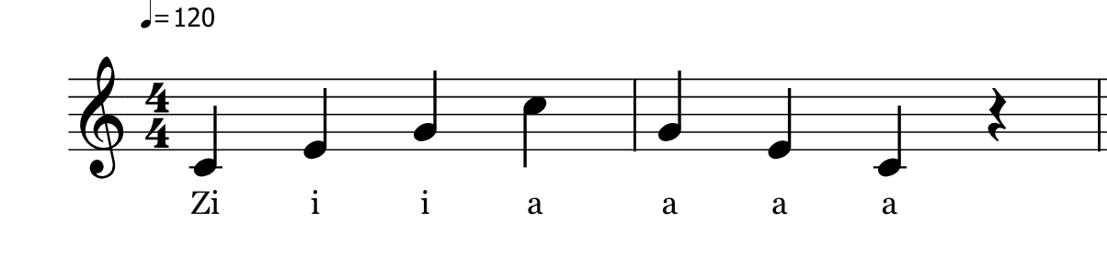
    - Focus on open vowels and sharp consonants
    - Sing from C4-A4
- Discuss the background of the piece “Fire Fire”
  - Begin with teacher directed answers
    - 16th century musical style started in Italy
      - Migrated to England
    - Polyphonic and unaccompanied
      - Mix of poetry and music
      - Stemmed from religion of the Roman Catholic Church
- Introduce “Alfred the Alligator song”
  - Sing unison
  - Sing in a cannon or round with three different voice parts
    - Emphasize importance of independent lines, repeating lines and phrases,
    - Associate the warm up song concepts to “Fire Fire”
      - i.e “Fire fire” words repeat in different voice parts at different times
      - i.e “My heart, Fa la la” appears in a cannon like structure
- 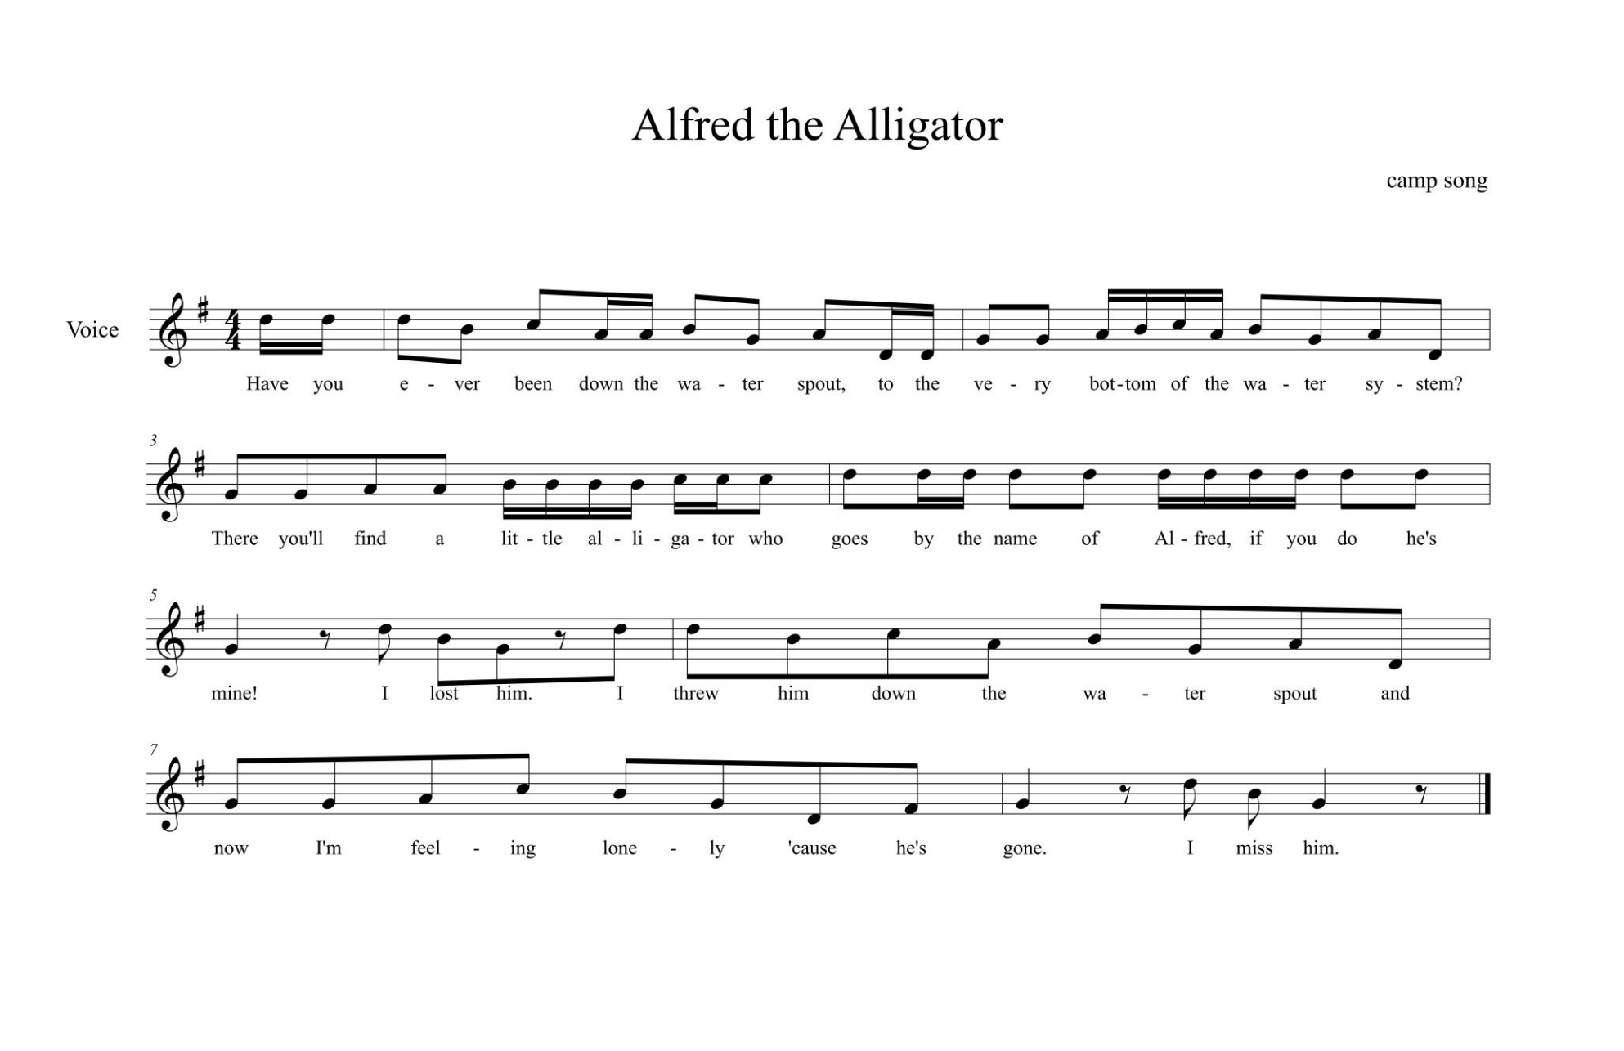
  - Continually check for correct posture, breathing, diction, and rhythmic detail
- The study of Fire, Fire by Thomas Morley Arranged by Russell Robinson
  - Begin study of the A section and C section (My heart and Fa la la)
    - Sing through entire A section with a mix of piano accompaniment and part playing
    - Stress the importance of word painting used in the 16th century style Madrigal
      - “Fire fire” depicts dancing flames in rhythmic, leaping figures
      - “Fa la la” section should be light and dance like
        - Fa should have a slight accent
        - Using the tongue to create separation in the wording of “Fa la la”
    - Repeat the same concepts for the A’ section
      - Although the text is using similar wording, the piece is considered through-composed as the rhythm attached to the wording is different
  - Begin the Study of the B section
    - Sing through the entire B section with a mix of piano accompaniment and part playing
    - Stress the importance of dynamics
      - Using dynamics with repetitive text allows for the piece to enhance its musical quality and structure
    - Stress the importance of using dynamics in place of vibrato, as vibrato was not a concept introduced until after the 16th century.
    - Change the vowel formant at the very end of each word
      - To stay consistent with the 16th century madrigal style, emphasize the importance of pure vowels and intonation.
      - Keeping the vowel formant the same until the end of the word allows for higher accuracy in intonation and continual phrasing
  - Conclude the lesson combining all the learned parts together (A, B, C) sections
    - Ask students important concepts discussed throughout the lesson as a reminder of what to pay attention to
      - Reinforcement as well as an informal assessment for retention of information
        - i.e “ask about dynamics, articulation, word painting”
Assessment:

- Have students perform in trios. A rubric can be used to grade the accuracy of dynamics, pitch accuracy, and vowel formants.
- After being taught a short summary of a madrigal. A short written assignment can be given to students to explain their knowledge of the madrigal style. This assignment can also include outside research for re-enforcement.
Evaluation:

Extension:

